**Customer Journey Map:**

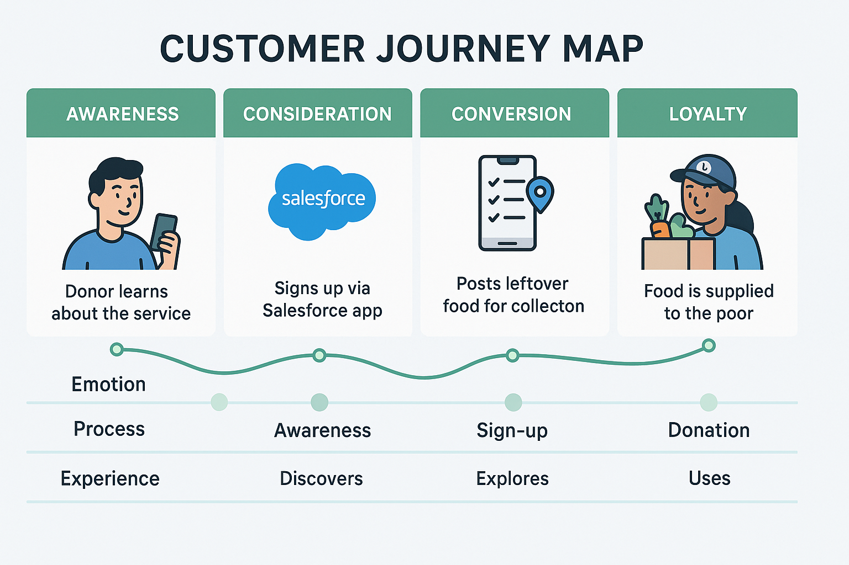

The customer journey begins when a restaurant or event organizer has leftover food and wishes to donate it. Using the Salesforce-powered web or mobile application, the donor registers and logs in to their account. Through a simple and intuitive interface built with Salesforce Lightning Web Components, the donor can submit details about the leftover food, including quantity, type, location, and pickup time.

Once submitted, the application logic, powered by Salesforce Flow and Apex, immediately routes this donation to the nearest verified NGO or volunteer group. The system leverages Salesforce Einstein AI to intelligently match food donations with recipients based on location, urgency, and perishability. The matched NGO or volunteer receives a real-time notification via Salesforce Process Builder or Apex Triggers.